Objectives:

* convert mW to currenthack optimization to give output. See if hypothesis works.
  + Update current spread to be over 1mm rather than every um. New units for current in nA/mm^2
  + Ensure luminous intensity units are correct
* new optimization opto(+) + Opto (-), no MS
* add 95% CI on Michaels plots
* discuss optimization with Dr gonzalo & Stephen mcAleavey
* Create optimization curves for iteration steps for MS, and MS + Opto (-). Create one for each so they can be animated.

This update: I dig deep into the fundamentals of the model to fix the units. I need to do this in order to be able to compare the current and optogenetic responses.

10uA = sphere with radius of 88um (~28 neurons) (Brandon ruszala) - Once we have raw data we can implement it and have a better relationship between distance and current.

Microstimulation:

**OLD PLOTS:**

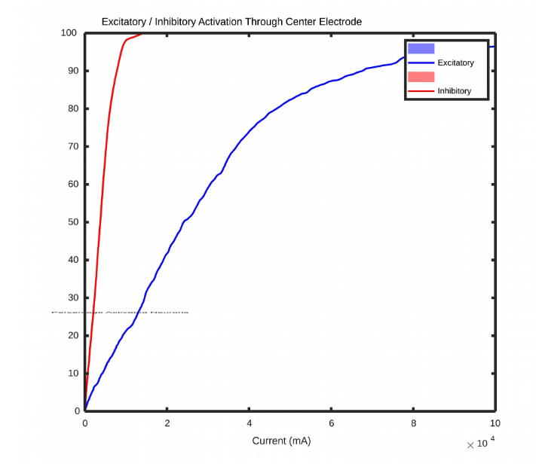



**NEW PLOTS:**





The units are now more in line to what we should expect. Important to note that the fundamental relationships have not changed. Only the scale has changed.

Optogenetics:

Imax 300 vs Imax 26. I believe this may have also been causing some scaling issues, as shown by the graph below comparing firing rate vs stimulus intensity.

n = 0.82; % Hill coefficient

Imax = 300; % Maximum FR

k = 0.49; % half maximal light sensitivity

fr = Imax .* ((x.^n)./((k.^n)+(x.^n))); % Equation



In this figure we can see the difference between using 26 (given by the paper) and 300 (our guess) as the maximal firing rate. This had a large impact on the model.

Optimization:



No solutions found for new combination opto(+) + Opto (-), with no MS.

I am confident that better solutions exist, but I am having trouble attaining this, as before. This is very likely a bounding issue where I need to fine tune the thresholds.

My proposal: Lets lower the number of electrodes in the model to simplify the optimization. I can give this a shot and see how it works.